# 20. Other

Content-Type: application/x-www-form-urlencoded

@PostMapping(value = **"/users/register"**, consumes = MediaType.***APPLICATION_FORM_URLENCODED_VALUE***)  
**public** String doRegister(@RequestBody MultiValueMap<String, String> paramMap){  
 System.***out***.println(paramMap.get(**"user"**));  
  
 **return "user/register"**;  
}

@PostMapping(value = **"/users/register"**, consumes = MediaType.***APPLICATION_JSON_VALUE***)  
**public** String doRegister(@RequestBody RegistrationDTO dto){  
 System.***out***.println(dto);  
  
 **return "user/register"**;  
}

@PostMapping(value = **"/users/register"**)  
 **public** String doRegister(**@Valid** RegistrationDTO dto, BindingResult validationResult) {  
*// RegistrationDTO dto = new RegistrationDTO("user", "pass", "pass", "mail@abv.bg");* **if** (validationResult.hasErrors()) {  
 **return "user/register"**;  
 }  
  
 **userService**.register(dto);  
  
 **return "user/login"**;  
 }

Пример за контролер

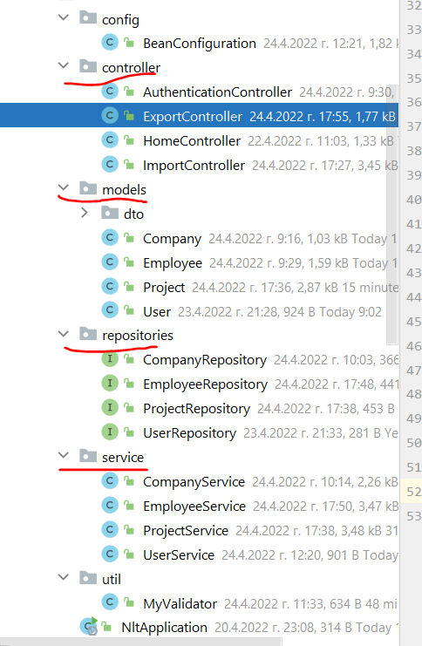 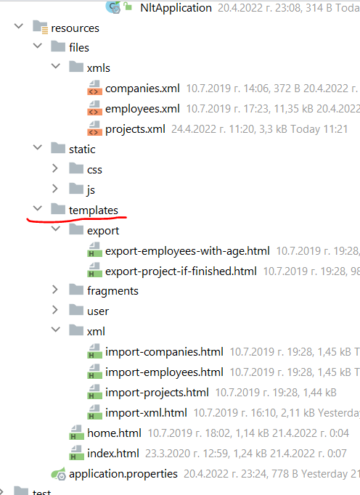

@Controller  
**public class** ExportController {  
 **private final** ProjectService **projectService**;  
 **private final** EmployeeService **employeeService**;  
 **private final** Gson **gson**;  
  
 @Autowired  
 **public** ExportController(ProjectService projectService, EmployeeService employeeService, Gson gson) {  
 **this**.**projectService** = projectService;  
 **this**.**employeeService** = employeeService;  
 **this**.**gson** = gson;  
 }  
  
 @GetMapping(**"/export/project-if-finished"**)  
 **public** ModelAndView showFinishedProjects(){  
 ModelAndView modelAndView = **new** ModelAndView(**"export/export-project-if-finished"**);  
  
 String result = **this**.**projectService**.getFinishedProducts();  
  
 modelAndView.addObject(**"projectsIfFinished"**, result);  
  
 **return** modelAndView;  
 }  
  
 @GetMapping(**"/export/employees-above"**)  
 **public** ModelAndView showEmployeesAbove25(){  
 ModelAndView modelAndView = **new** ModelAndView(**"export/export-employees-with-age"**);  
  
 List<ExportEmployeeDTO> employeesAbove25 = **this**.**employeeService**.getEmployeesAbove25();  
  
 StringBuilder sb = **new** StringBuilder();  
 **this**.**gson**.toJson(employeesAbove25, sb);  
  
 modelAndView.addObject(**"employeesAbove"**, sb.toString());  
  
 **return** modelAndView;  
 }  
}

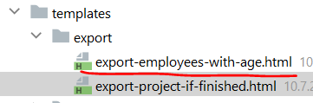

<!DOCTYPE **html**>  
<**html lang="en" xmlns="http://www.w3.org/1999/xhtml"  
 xmlns:th="http://www.thymeleaf.org"**>  
  
<**head**>  
 <**th:block th:include="~{fragments/head}"**></**th:block**>  
</**head**>  
<**body**>  
<**header**>  
 <**th:block th:include="~{fragments/nav-bar}"**></**th:block**>  
</**header**>  
<**main**>  
 <**div class="jumbotron"**>  
 <**form** >  
 <**div class="col-md-12 d-flex justify-content-center"**>  
 <**label class="display-4" for="export-project-textarea"**>Employees with age above 25:</**label**>  
 </**div**>  
 <**div class="col-md-12 d-flex justify-content-center"**>  
 <**div class="col-md-8 d-flex justify-content-center"**>  
 <**textarea class="form-control" id="export-project-textarea" rows="20" th:text="${employeesAbove}" readonly**></**textarea**>  
 </**div**>  
 </**div**>  
 </**form**>  
 </**div**>  
</**main**>  
<**footer**>  
 <**th:block th:include="~{fragments/footer}"**></**th:block**>  
</**footer**>  
</**body**>  
</**html**>

<**div class="form-group"**>  
 <**label for="number" class="col-lg-2 control-label"**>Number</**label**>  
 <**div class="col-lg-10"**>  
 <**input type="text" autofocus="autofocus" name="number" title="Number" class="form-control"  
 pattern="\+?[0,9]{6,}" //валидира за телефонен номер с регекс  
 id="number"**/>  
 </**div**>  
</**div**>

## Uploading a file

@PostMapping(**"/"**) *//покажи всички***public** String storeContact(Contact contact, @RequestParam(**"picture"**)**MultipartFile** picture) {  
 **this**.**contacts**.add(contact);  
  
 **return "redirect:/"**; *//върни ме на началната страница*}

<**div class="form-group"**>  
 <**label for="picture" class="col-lg-2 control-label"**>Picture</**label**>  
 <**div class="col-lg-10"**>  
 <**input type="file" autofocus="autofocus" name="picture" title="Picture" class="form-control"  
 id="picture"**/>  
 </**div**>  
</**div**>